PPIT Project - Documentation

**Introduction**

This project is designed to help a fitness instructor get a better communication with their client. It is designed for clients to post their workout’s so that the trainer can keep track of who is completing their daily fitness task’s. The user can post a picture of them performing the exercises assigned to them by the fitness instructor.

The fitness instructor has an administrative role where he can access the video page and has permissions to add or delete a video. This part of the website is used so the instructor can post different videos that his clients can follow to help them perform the exercises they were assigned. The page is based on 3 different types of sports such as running, swimming, and weightlifting. The users can change what type of content they can see by using the selection menu on the right-hand side of the video page.

**System Requirements**

What the user will require to use this website is an internet connection and preferably a pc/laptop. A phone would also work but the user would get the best user experience on a larger monitor.

**Technology Used and Why**

* Angular
  + After doing some research we found that Angular is a good framework to use for making single page client applications.
  + It also provided us with some nice, modern styling for our website as we had access to the angular material library which helped us with constructing consistent web pages.
* NodeJS
* Firebase
  + We decided to use firebase as our front-end & back-end database. We went with firebase because it is a cloud-based database, so it was easier to work with. We knew we were going to be using user authentication and firebase decreases the complexity of that so that’s why we went with firebase over MYSQL.
* Typescript
  + We used typescript as the angular already implements typescript into its framework.
* HTML
  + We also used HTML to help with the structure of our website.
* CSS
  + We used CSS to help with the styling of our HTML code.

**Architecture of the Solution**

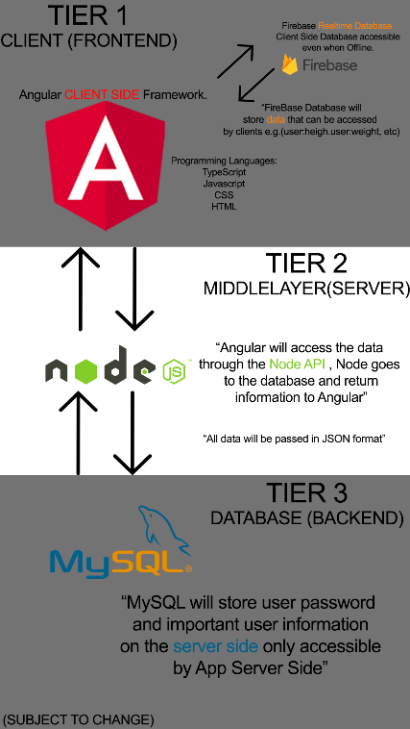

**Design Methodology Applied**

* Discovery
  + When we started this project, we began by researching different ways we could create a website and what would be the best framework to use after some research we decided to go with Angular as it is one of the most popular frameworks for web development. We also have had some experience of using Angular before in 2nd year of our course.
* Planning
  + Once we figured out our framework, we began planning what we want this website to be and what other technology we would need to develop this website. We knew we would need some sort of database, so we went with firebase. At first, we were going to use MYSQL as our database, but we decided to use firebase as it is a cloud based database and it works well with angular to decrease the complexity of user authentication and user authentication was going to be a big part of our website.
* Creative
  + We would have weekly meetings where we would discuss our plan for the week and what we were planning on doing, the meetings were great as it helped us have a clearer vision of what the project would look like and as a team, we could actually discuss things and catch up on what everyone has done. The meetings also allowed us to give each other constructive criticism on things that we should maybe do or things that might not be worth doing. This would help a lot with the creative side of the project as everyone on the team could give their own ideas and we would come to a conclusion of what we should do with the project.
* Application
  + Once we had a plan of what we are going to work on each week we then assigned different roles to each other of who was going to do what task. Must of the time one person worked one day on the project and the other day it was someone else. We used a scrum board on GitHub to track some of the things that we need to get done.

**Software Development Life Cycle**

* Planning
  + We used our weekly meetings to do most of the planning for our project. In the meetings we could discuss what we are planning on doing each week.
* Requirements
  + Some main requirements for the project were that user’s could create their own account and successfully log in and have access to their own profile.
  + Also that the fitness instructor would have access to administrator roles and could add or delete videos on the video page.
* Design
  + The main structure was that the left side would be the navigation bar between pages, the middle column would be the user’s feed posts and on the right-hand side we would have specific features relating to the specific page the user was on.
  + At the beginning before we began coding the website, we created a project map so we would have a better understanding of all the technology we are using and how it will all link with each other.
* Build
  + As we had made a project map, we knew what we were using for the project so when we started coding it was easy to follow what tools and languages, we needed to build the project.
* Test
  + To test the project, we used Selenium’s chrome extension. We decided to use this as we had some experience with it in one of our modules in 3rd year.
* Deployment / Maintenance
  + After the product was tested and we found there were no major bugs that would disrupt the user experience we used firebase to host our project on the web.

**Features of the Implementation**

What we did to keep the project on time and make sure there is consistent work done on the project, we held weekly meetings. This way it made everyone on the team consistently do some work on the project so when we would meet next week there would be some new work done to show to the team. We also used a wiki on GitHub to keep track of everything that was done in the week and what the plan was for next week this way we remembered what we had planned to do and it kept everyone on the team accountable to do the work as they said that’s what they are going to do and if they didn’t do it everyone at the meeting next week would know as there would be no progress on the project from last week.

**Limitations & Known Bugs**

There is no one on one private chat between administrator and user.

You cannot view other people’s profiles.

Users can’t interact with other user’s posts.

**Testing Plans**

For the project we done unit testing, we used selenium’s chrome extension to test different parts of the project as we went along. We made sure to test the log in page so the user can create an account and make sure he can then actually log in once the account is created, and his information is stored on the firebase database.

We also tested the feed section of our project. We tested if the user can post information on the feed without any bugs.

**Recommendations for Future Development**

Some weeks we planned to much for the week and we did not get it done. I would say just plan less for the week but if you get it done just plan something else you can do that week. Because some weeks we planned to much and we had to move it into next week and then we had other plans already for that week, so a lot of things were just getting on top of each other at some stages throughout the project.

Do more frequent testing as we did not perform a test every week. If we done more testing, we could have potentially found the bugs faster and got them fixed. As we found some small bugs at the end that could have been fixed earlier on if we had tested the website.

Some more frequent meetings for example if you have a meeting on Wednesday and get stuck on a problem on Thursday and you need people on the team to help you try to get in contact before the meeting next week to solve the problem you encountered.

**Conclusions**

What we learned from this project is how important communication is. If we had not communicated as a team, we could have planned to do the same stuff each week and that would slow down the development of the project. So, when we communicated it helped us properly plan what we will do and what task each person has for the week.

We also learned it’s important to properly research what tools/technology you will be using for the project and if they will allow you to perform the things you will need for the project.

It is also very important to stay consistent with your project and keep on top off all the work you plan on doing each week. Some weeks you will not get everything done you planned on doing but make sure you don’t decide to take a few days off because you done a lot in one week so you can now take a day or two off.